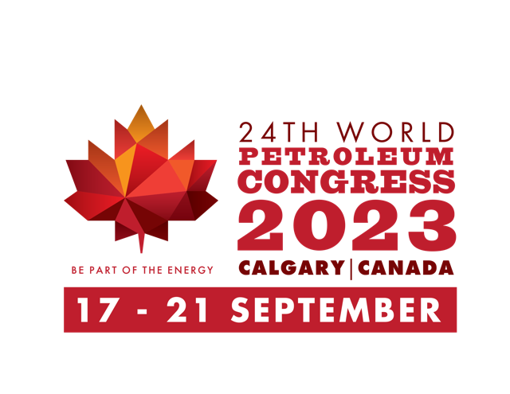

Press Release
Calgary goes bold with Net Zero theme for 24th World Petroleum Congress; Call for Papers Launched
March 14, 2022 I Calgary, Canada
The 24th World Petroleum Congress (24th WPC) Organizing Committee announced today the launch of the ‘Call for Papers’ inviting innovative ways to manage the global industry’s challenges. Under the theme “Energy Transition – the Path to Net Zero”, the Congress will profile innovative clean technology that reduces carbon emissions throughout the full spectrum of the energy sector around the world in support of the transition to make net zero a reality.
As the flagship event of the World Petroleum Council (WPC), the 24th edition of the Congress will take place in Calgary, Canada, September 17-21, 2023. The triennial Congress attracts the highest-level industry and government leaders from around the world, including heads of state, ministers of energy and C-suite executives. More than 15,000 attendees, 200 international exhibitors and 100+ countries are expected to participate in the Congress at the BMO Centre, Stampede Park in Calgary.
The Congress themes highlight the direction of the World Petroleum Council. While past themes have focused on best practices in the industry, the theme of the 24th Congress demonstrates the Council’s focus on the need to reduce carbon emissions within the global energy industry. The theme of "Energy Transition - the Path to Net Zero” will examine various possible pathways to a net zero future through 4 main subject blocks across 17 technical forums.

“This theme is important for the World Petroleum Council and its members, and it reflects the exciting future in the global energy industry”, said Pedro Miras, President, WPC.

Denis Painchaud, President of the Canadian Organizing Committee for the 24th WPC, said “A lot of what happens in Calgary will help shape the direction of the global energy industry in the years to come. Conversations will help define realistic, workable paths to a net-zero future and help elevate the energy sector for the next 25 years and beyond”.

"We will have an excellent Technical Program at the 24th Congress focused on the reduction and elimination of GHG's. Covering a wide variety of topics such as Hydrogen, Carbon Capture Utilization and Storage, Towards Zero Methane Emissions, and Cleaner Fuels, to name just a few, the program will not only address emissions reduction but other sources of low or zero emission energy and the application of clean technologies," added Dean Tucker, Vice Chair WPC Canada and COO of the Canadian Organizing Committee for the 24th WPC.
To recognize the scientific, technological and professional achievements across the energy value chain, authors are invited to share their expertise towards the specific technical forums. Submit before 7 July 2022, by submitting abstracts for paper and poster presentations at www.24wpc.com and address the way forward in managing emissions from a variety of energy sources.
View Call for Paper Topics: https://www.24wpc.com/call-for-papers-open
About The World Petroleum Council
The World Petroleum Council was established in 1933 and provides a neutral platform for discussion of the issues facing the oil and gas industry and its stakeholders around the globe. It is a non-advocacy, non-political organisation, dedicated to the application of scientific advances in the oil and gas industries, technology transfer and the sustainable use of the world’s petroleum resources for the benefit of all. The WPC is registered as a charity in the UK. Its 60 member countries represent 95% of the world’s oil and gas production and consumption.The triennial World Petroleum Congress is the oil and gas industry’s largest and most prestigious international event.
www.world-petroleum.org
About the 24th World Petroleum Congress
The 24th World Petroleum Congress takes place in Calgary, Canada, September 17-21, 2023. The triennial World Petroleum Congress is the premier energy forum to address the biggest challenges facing the future of the energy sector. Assembling expert speakers from all around the world, the Congress attracts the highest-level industry and government leaders, including heads of state, ministers of energy and C-suite executives.
www.24wpc.com

For further information on the 24th World Petroleum Congress, contact:
Richard Masson, Press and Media Relations
richard@wpccanada.com

